TECHNOLOGY IN THE CLASSROOM AT BUCKLEY PARK COLLEGE

Technology is a driving force in the world today. It also introduces some remarkable opportunities for schools to expand what is possible for teaching and learning. For that purpose, we implemented the bring-your-own-device (BYOD) program, which offers all students the option to use a personally owned device for their own learning. The use of this device is not only for the direct learning in the classroom but is also essential to preparing students for life, leisure and work in the modern world.

Since the beginning of 2014, the school community has been highly supportive of the BYOD approach. This approach allows students and parents the flexibility to decide which device is most suitable for their needs and budget. All Buckley Park College students are required to participate in the BYOD program.

About BYOD @ BPC
- Students and parents make a decision about which device might best suit their needs and budget from the ‘Suitable Devices List’ (see below).
- Purchase the device. It is strongly recommended that parents consider add-ons like cases, carry bags, accidental damage insurance and extended warranties.
- Our IT technicians connect the student device to the school WiFi network in the first week of the term 2020.

Suitable Devices
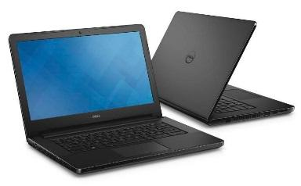 |  | 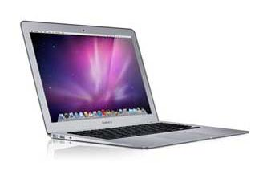
Windows notebook  OS: Windows 10  Wireless Compatibility: Device must have 5GHz 802.11n support |  | Apple Mac notebook  Macbook, Macbook Air, Macbook Pro  macOS 10.11 or newer  Wireless Compatibility: Device must have 5GHz 802.11n support

Please Note:
- Android Tablets, Chromebooks and iPads are not accepted.
- iPads will be phased out from the start of 2020.

Making a Decision about BYOD
2019 the device profile for Years 7-10 (over 600 students) was:
 | % of Students (7-10) | Advantages | Disadvantages
Windows Notebooks | 42% | Familiarity, range of software | May be heavy, quality varies
Apple Macbooks | 58% | Great built-in software | Unfamiliar for Windows users

Perhaps the most important factor is battery life. The selected device must be able to last the entire school day (6 hours) without needing to be charged. Charging is not permitted at school, and students should not bring chargers with them.

About Google @ BPC

The school has a Google Suit for Education account, which benefits students in the following way:
- All students have a school ‘Gmail’ account
- Students have unlimited cloud storage on Google Drive
- Google Docs, Sheets and Slides provide free access to cloud-based productivity software (that is similar to Microsoft Word, Excel and PowerPoint)
- Central to student-teacher communications is Google Classroom

About Compass @ BPC
The school uses Compass to communicate day-to-day information between parents, students and teachers. These communications are particularly focused on attendance, assessment and reporting. Important school-wide messages are distributed via Compass.
Students each have an individual Compass account. Each family also has a Compass account, for the exclusive use of parents and guardians. It is important that these accounts are kept secure. Usernames and passwords are distributed at the beginning of the school year.

Software and Anti-Virus
A variety of useful software is available via the EduSTAR Catalogue this includes Adobe and Office 365. As this is for school users only, a username and password is required. This information can be provided to students in early 2021.

Please direct any enquiries to the BYOD Coordinator.

